TẬP ĐOÀN CÔNG NGHIÊP
VIỄN THÔNG-QUÂN ĐỘI
VIETTEL



DESIGN SPECIFICATION

MODEL

COUNTER WRAPPER



Author: Huan Nguyen-Duy
Date: 8/20/2024

CATALOG
1. OVERVIEW 4
2. ARCHITECTURE 5
3. SEQUENCE DIAGRAM 6
4. ACTIVITY DIAGRAM 7
4.1. Nb_transport_fw 8
4.2. Output_handling 9
4.3. Input_handling 10

FIGURE
Figure 1 : Counter wrapper architecture 5
Figure 2 : Sequence diagram 6
Figure 3 : nb_transport_fw flow diagram 8
Figure 4 : output_handling activity diagram 9
Figure 5 : Input_handling activity diagram 10

TABLE
Table 1 : Variable definition of class bus 8
Table 2 The list of functions 10

OVERVIEW
This document illustrates detail design of wrapper counter model using systemC. Counter module is worte by verilog that is converted to systemC interface using tool v2sc, it is provided by Mazdak and Alborz authors.

Link tool v2sc
:: V2SC Product :: (mazdak-alborz.com)

ARCHITECTURE
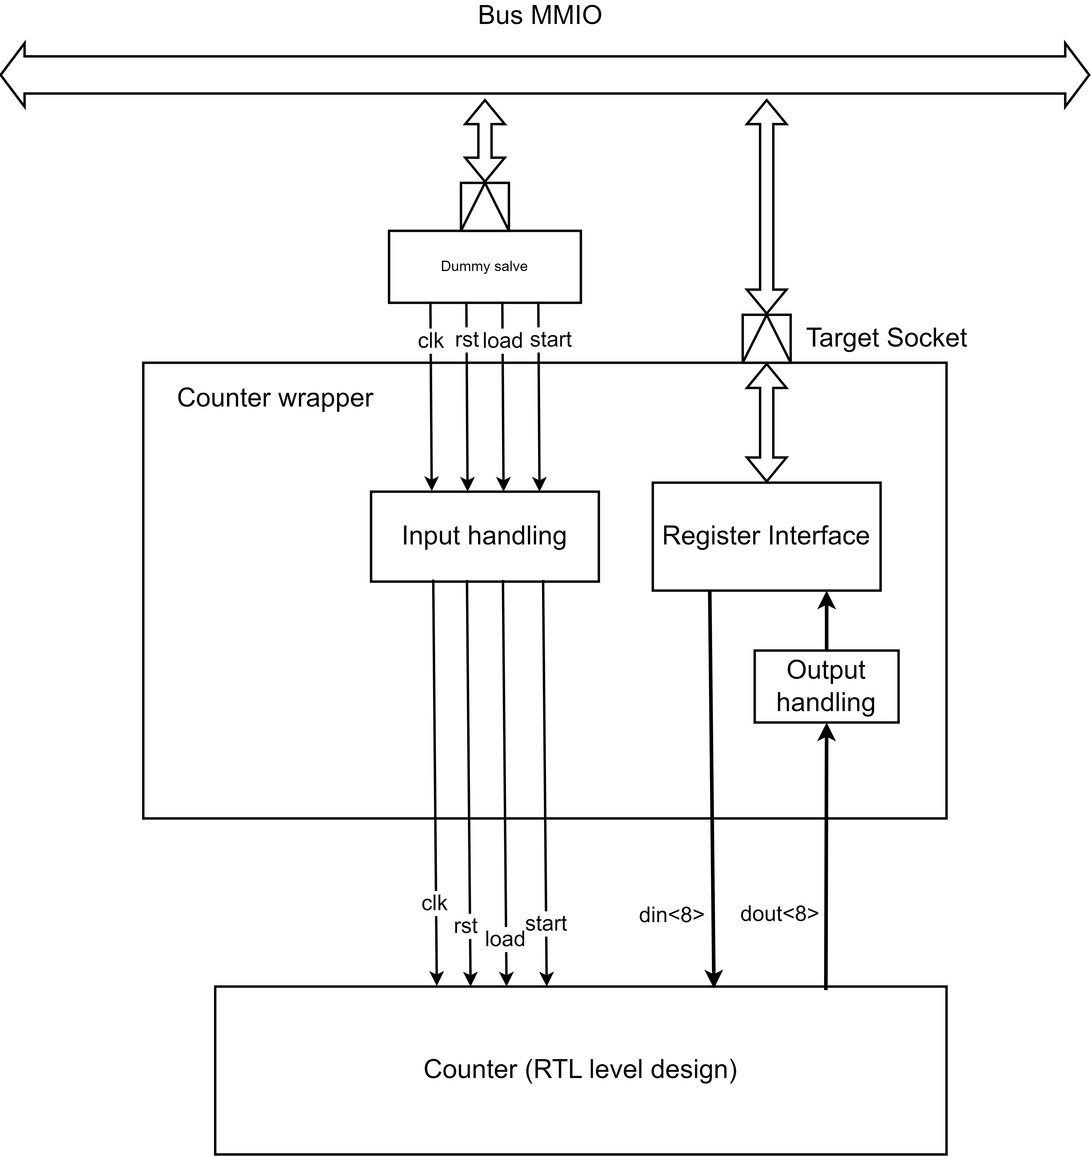
Figure 1: Counter wrapper architecture

The fig 1 shows detail design of counter wrapper model. The signals are forward directly through input handling method and in/out registers are mapped into register interface. It can be accessed by a TLM socket.

SEQUENCE DIAGRAM
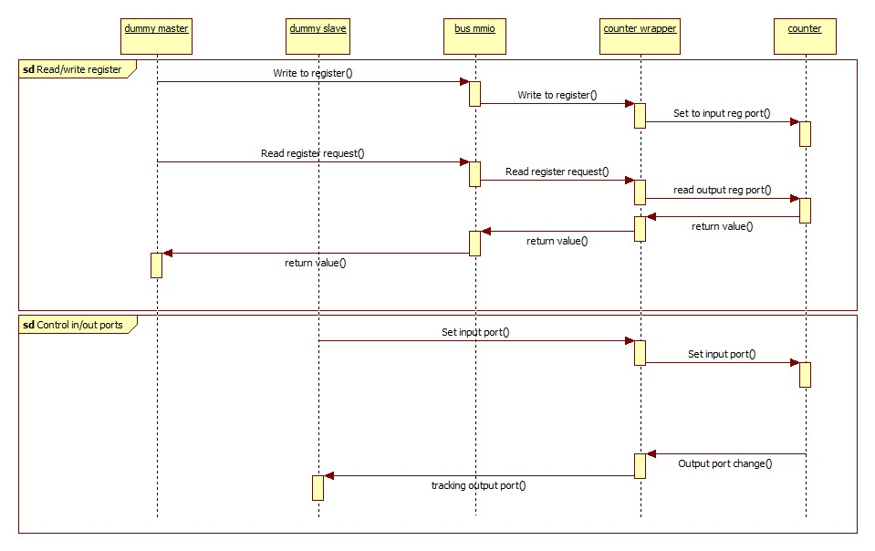
Figure 2: Sequence diagram

The counter wrapper supports read and write register through tlm target socket interface. Furthermore, ports can be accessed directly by using dummy slave or other models.

ACTIVITY DIAGRAM
In this chapter, the document provides all important activity digram of counter wrapper model.

Nb_transport_fw
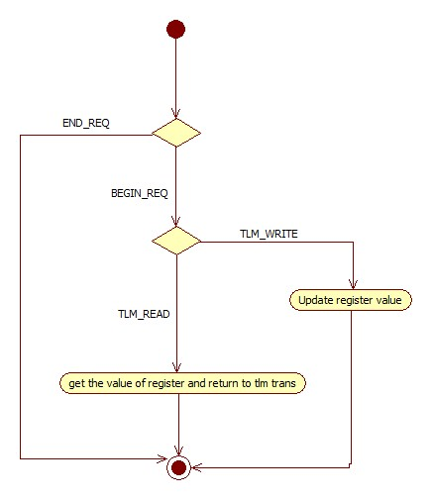
Figure 3: nb_transport_fw flow diagram

This function is called when the target socket receives data from bus. In this function, depending on TLM read or write command, the counter wrapper model assigns value to the corresponding register or reads value from the corresponding register, retuning this value to master.

Output_handling
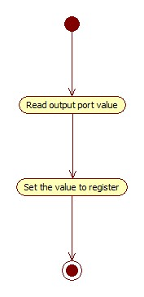
Figure 4: output_handling activity diagram

The output_handling function is used to synchronize the output ports and reg ports of counter module with output port of the counter wrapper model and its register interface.

Input_handling

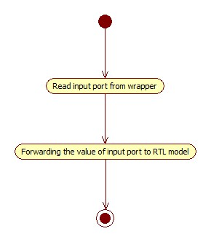
Figure 5: Input_handling activity diagram

This function is used to synchronize input ports between wrapper and RTL module.

